**HOTEL MANAGEMENT SYSTEM**

**Group Members**

Karthik Nair AM.EN. U4AIE21138

R Aravind AM.EN. U4AIE21151

Vishnu Shaji AM.EN. U4AIE21167

Akhilesh AM.EN. U4AIE21108

M SOWJIKRISHNA AM.EN. U4AIE21181

**ABSTRACT**

The purpose of this section is to state the Goal and Objectives of the Software Project.

This project aims at creating on Hotel Management System which can be used by Receptionist, Admin and Customers. A person can book a room by providing his details. He will get a unique customer id. He can use that customer id in other expenses within the hotel and the total amount will be stored and can be paid at the time of check out.

Additional packages come with special health, beauty and care services that can be accessed with customer id. Customer can choose a service at a time and amount will be stored in his object.

Restaurant can be also accessed with customer id. Customer can book the food by providing the number labelled to the food name and giving quantity. The bill will be displayed and will be added to the customer object.

Taxi service comes with different options like rental, drop, pickup etc. To consider customers that are not in hotel, taxi service can be accessed without customer id.

The report of every customer can be accessed by admin by using his password.

**Functional Requirements of the System**

1. Customers need to enter their personal information and need to decide their type of room to be booked and pay the advance amount.
2. Customers can access Restaurant Service
3. Customers can access additional packages like Spa, Saloon and Fitness Center.
4. Customers and outsiders can access taxi service provided my hotel.
5. At the time of checkout Customers must pay the final bill including all other services they have accessed during their stay in hotel. Full report of the stay will be generated.

**Use Case**

|  |  |
| --- | --- |
| **Actors** | **Use case** |
| **Admin** | All information |
| **Receptionist** | Check in, Check out, Additional Packages, Taxi |
| **Customer** | Restaurant |

**USE CASE DIAGRAM**

**Use Case Description**

|  |  |
| --- | --- |
| Use case ID | Check in |
| Brief description | The customer provides personal details and his/her choice of rooms. |
| Primary actors | Customer, Receptionist |
|  |  |
| Precondition | The Customer must provide personal info and room information. |
| Post condition | Customer gets the room booked. |
| Main success Scenario | The Customer gets the confirmation and advance payment bill |
| Actor Action | System Response |
| 1. Customer asks for room and gives personal details | Will display the details of customer with customer id |
| 2. Shows the room details and selects the room | Advance payment and confirmation message |

|  |  |
| --- | --- |
| Use case ID | Restaurant |
| Brief description | The customer can book food. |
| Primary actors | Customer |
| Precondition | The Customer must give customer id and book the food. |
| Post condition | Food gets booked. |
| Main success Scenario | The Customer gets the confirmation and amount will be added to database. |
| Actor Action | System Response |
| 1. Customer selects menu | Will display the menu |
| 2.Customer ordering food. | Will display confirmation message, bill and amount will be added to database |

|  |  |
| --- | --- |
| Use case ID | Taxi |
| Brief description | The customer and outsiders can access taxi services |
| Primary actors | Customer, Receptionist |
| Precondition | The Customer must provide his details |
| Post condition | A taxi gets booked. |
| Main success Scenario | The Customer gets the confirmation. |
| Actor Action | System Response |
| 1. Customer request taxi service | Will display the available options |
| 2. Customer Can choose appropriate option | Will return confirmation message and bill |

|  |  |
| --- | --- |
| Use case ID | Additional Package |
| Brief description | The customer can access additional packages provided by hotel |
| Primary actors | Customer, Receptionist |
| Precondition | The Customer must give customer id and book the service |
| Post condition | Service gets booked, and added to database |
| Main success Scenario | The Customer gets the confirmation and amount will be added to database. |
| Actor Action | System Response |
| 1. Customer selects addition package | Will display the available sevices |
| 2.Customer choosing appropriate service | Will display confirmation message, bill and amount will be added to database |

|  |  |
| --- | --- |
| Use case ID | Check out |
| Brief description | The customer provides customer id and gets final bill and pays it. |
| Primary actors | Customer, Receptionist |
|  |  |
| Precondition | The Customer must provide customer id |
| Post condition | Customer gets the bill. |
| Main success Scenario | The Customer gets the bill and pays it |
| Actor Action | System Response |
| 1. Customer gives customer id | Displays bill |

**CLASS DIAGRAM**

**User input and Output**

CHECK IN

When the person first do’s the check in.

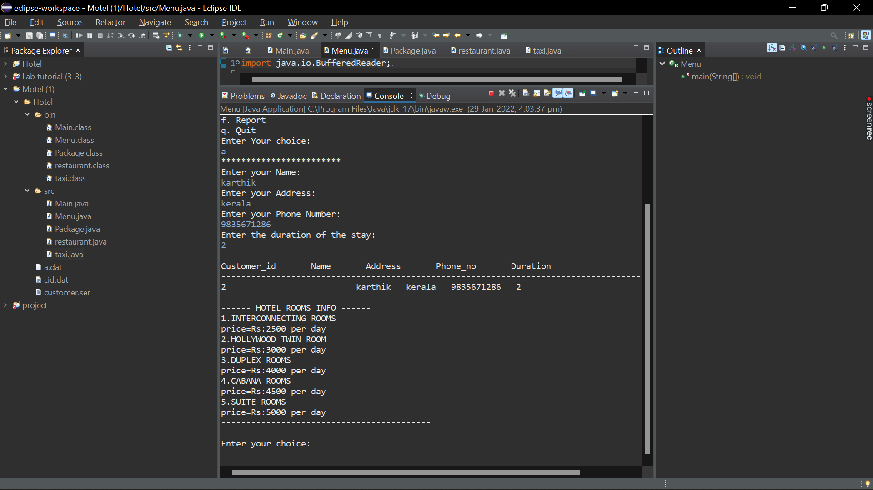

The person has been asked the type of room to be provided and also the person can select the room according to their wish.

ADDITIONAL PACKAGES

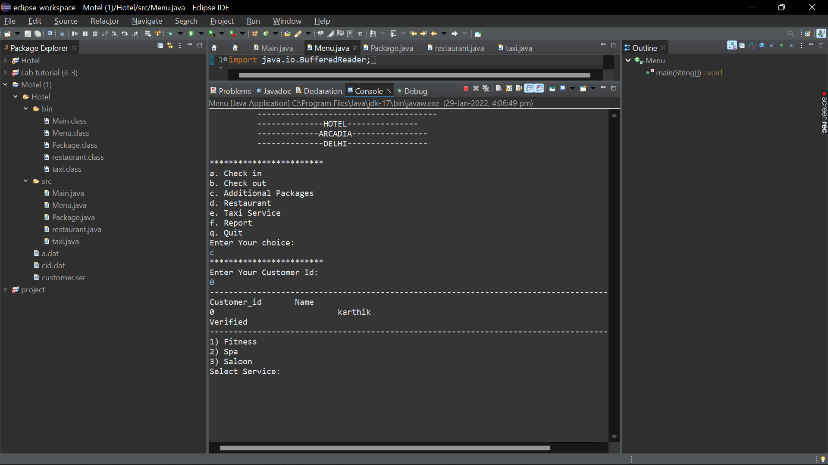

The person can choose different types of packages they need.

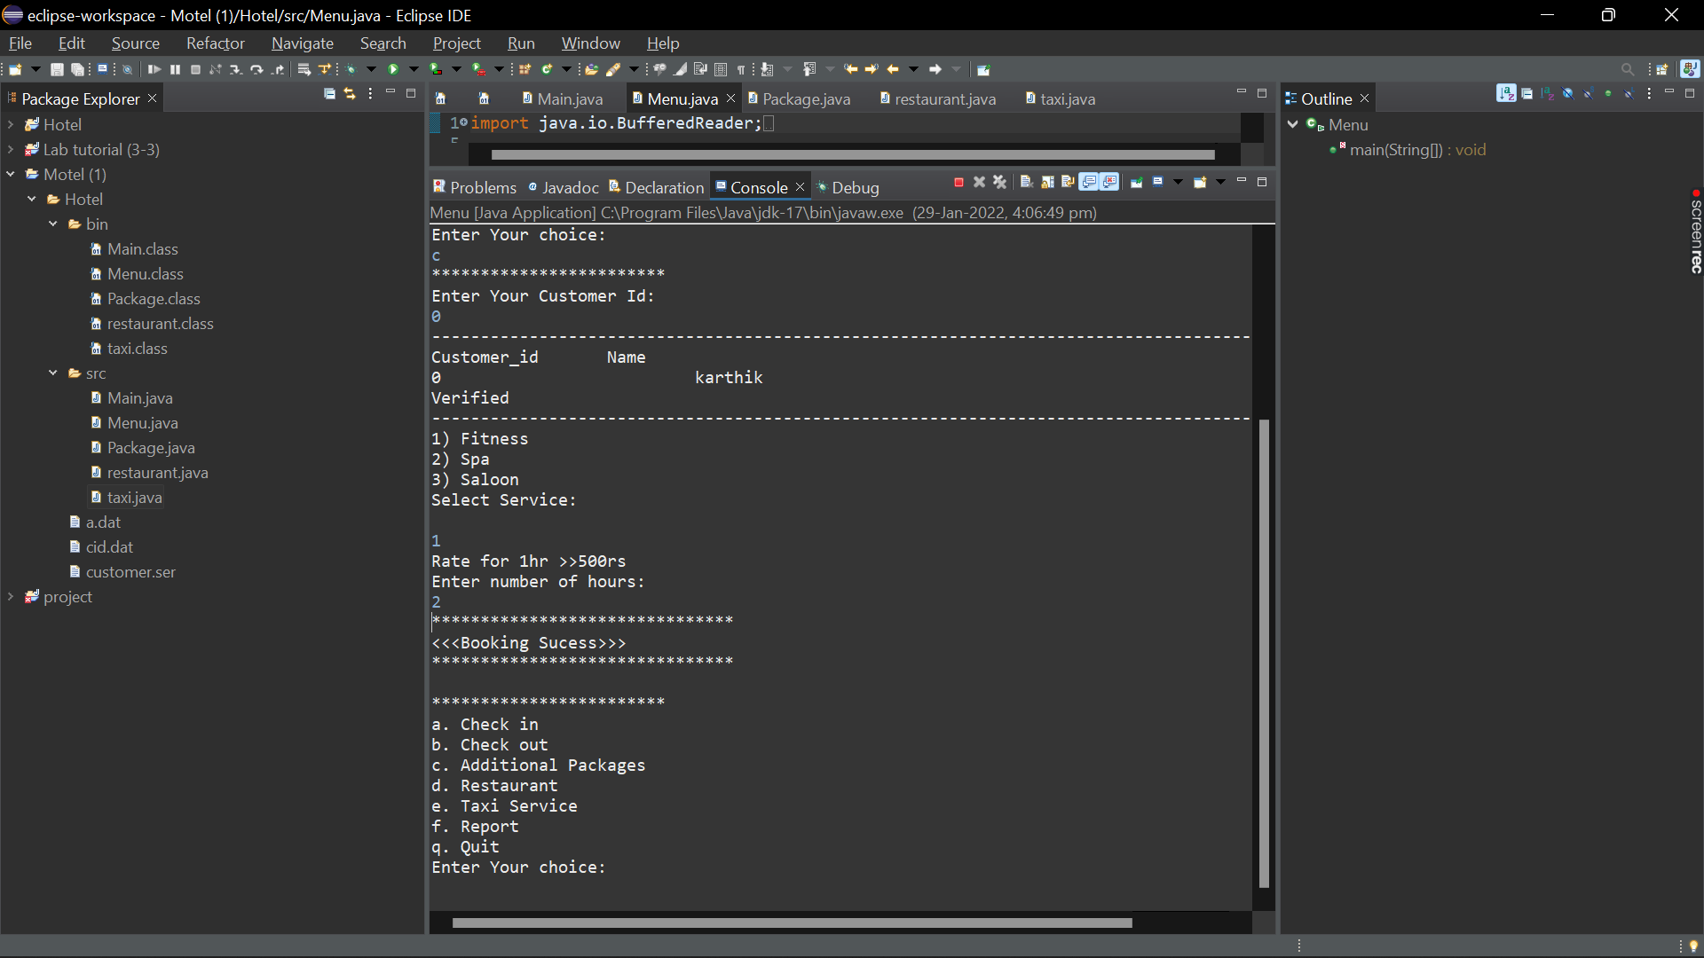

The person must enter till what time he will be using the package.

RESTAURANT

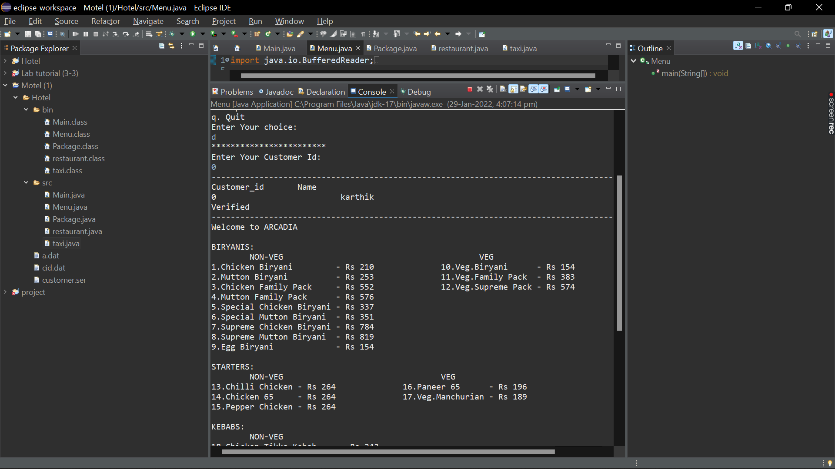

The person must select the different foods he need.

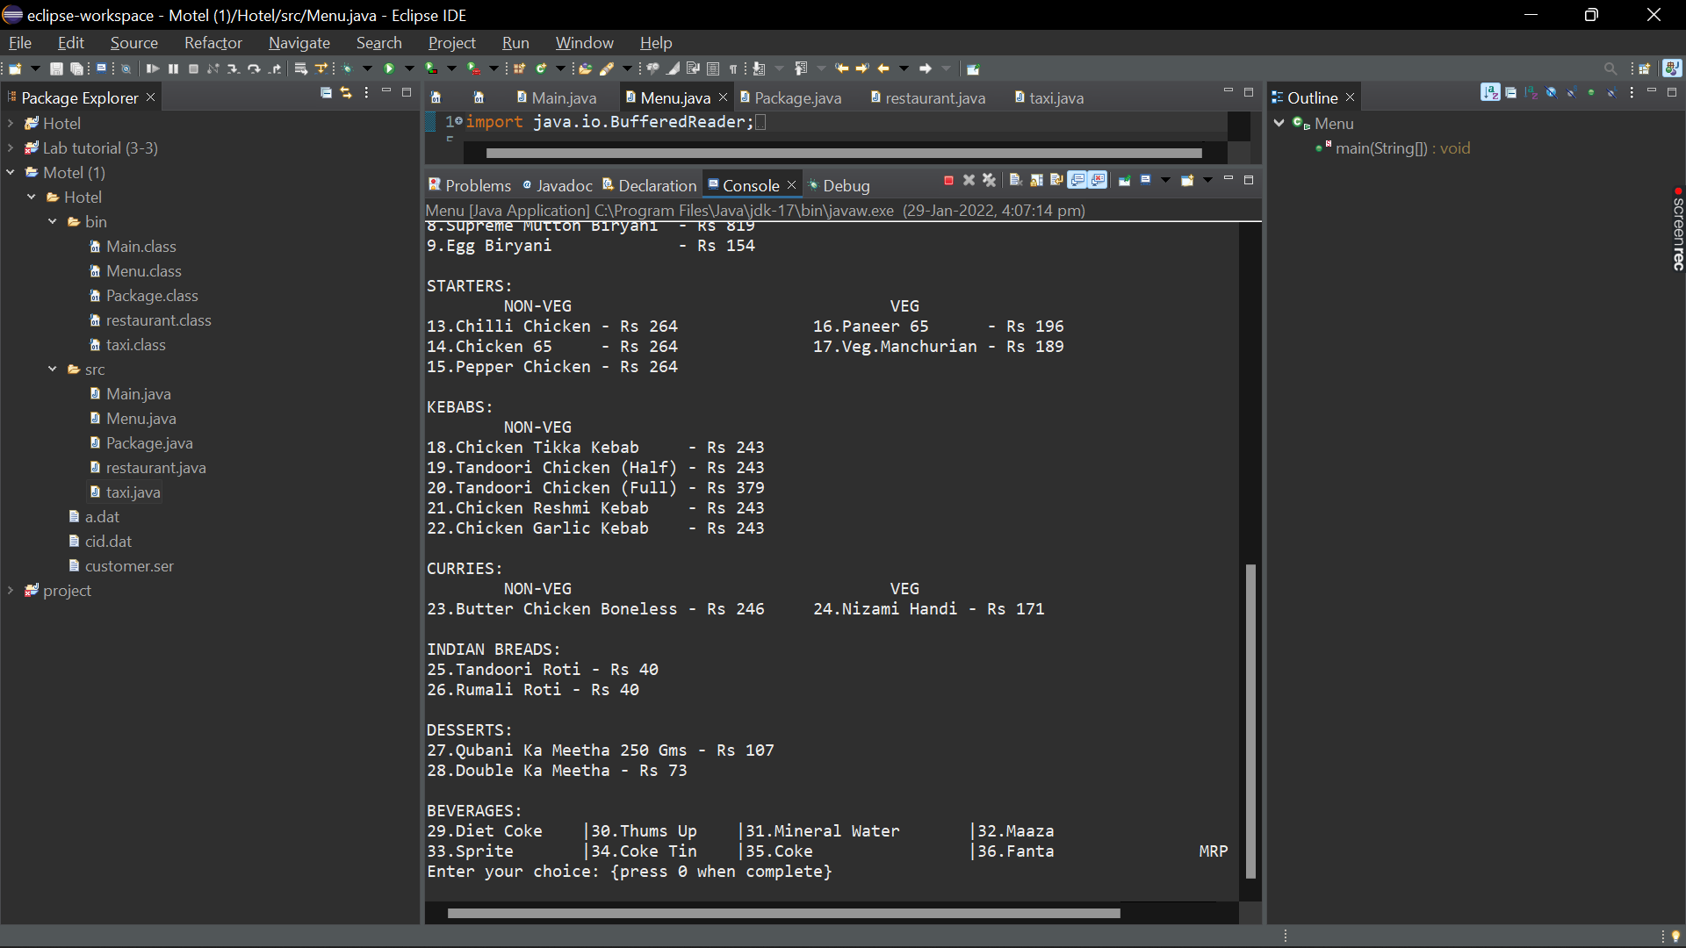

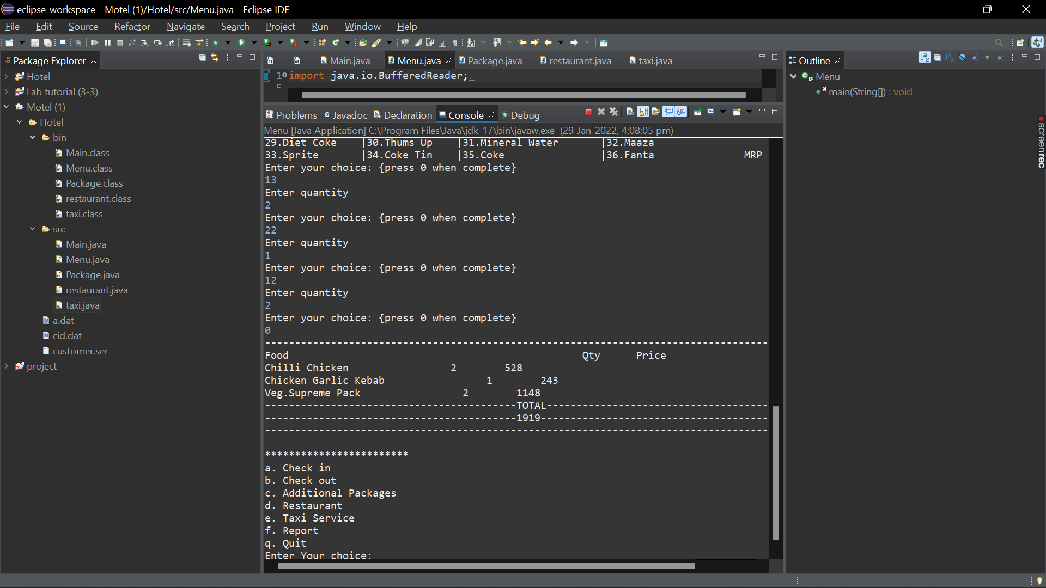

The person must select the quantity of food he needs.

TAXI

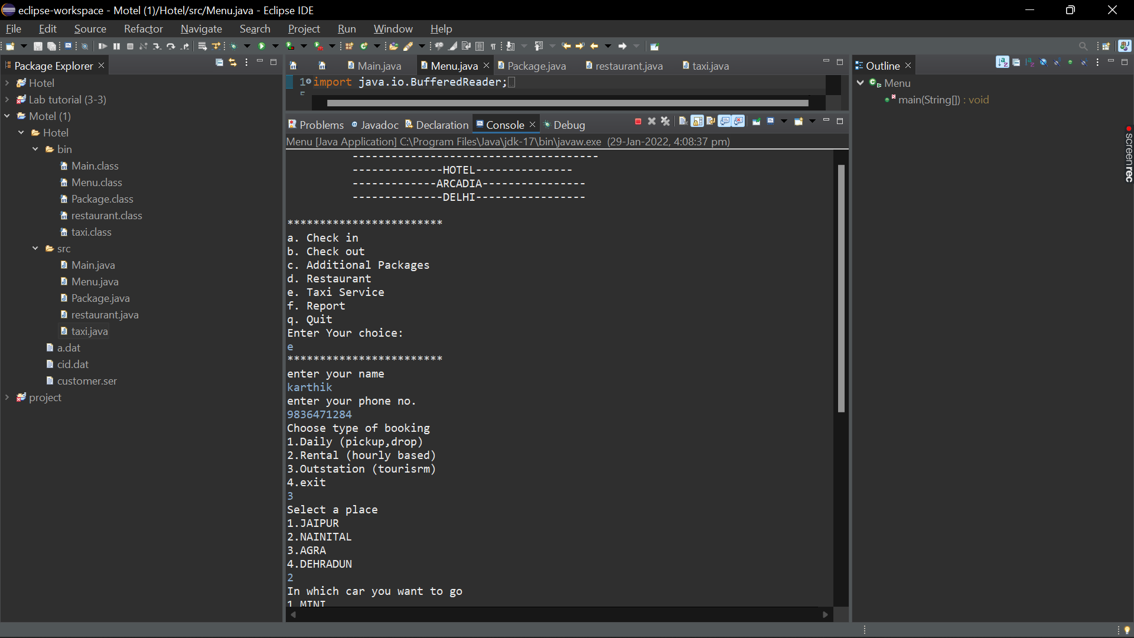

The person has to select the type of booking and also, he need to select the place he need to visit.

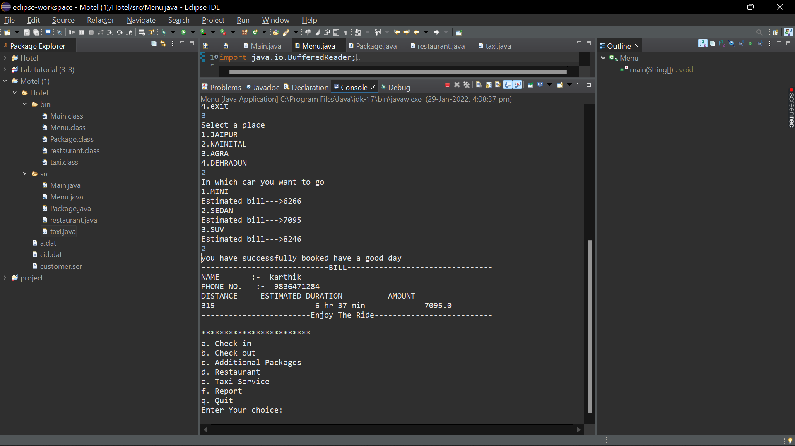

He must select the type of car according to the need and he can see the bill.

REPORT

The admin can access every customers details